[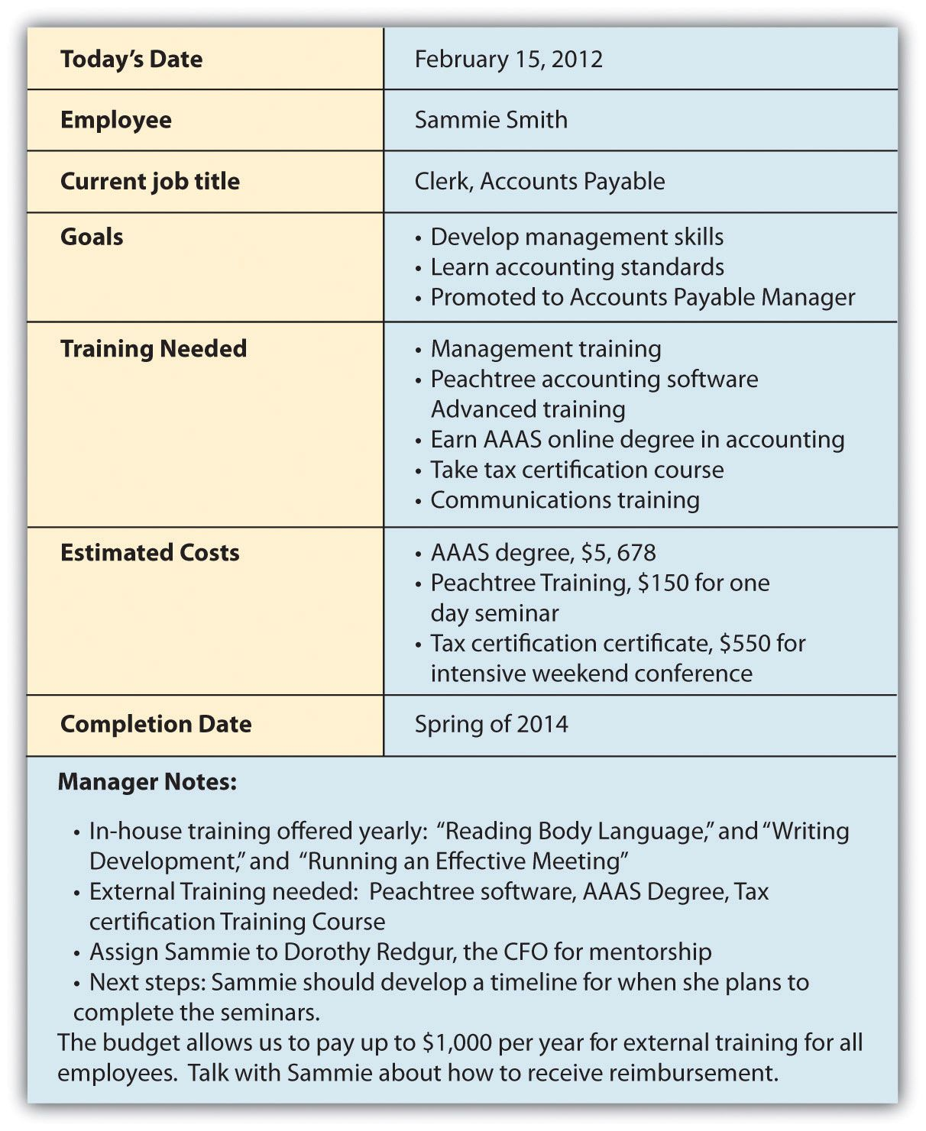](http://www.google.com/url?sa=i&rct=j&q=&esrc=s&source=images&cd=&cad=rja&uact=8&ved=2ahUKEwiX9IHG2LbhAhVh6IMKHY0_BQwQjRx6BAgBEAU&url=/url?sa%3Di%26rct%3Dj%26q%3D%26esrc%3Ds%26source%3Dimages%26cd%3D%26ved%3D%26url%3Dhttps%3A%2F%2Fwww.pinterest.com%2Fpin%2F222435669071162017%2F%26psig%3DAOvVaw2ZWmBH5e2---ihAl50CI1B%26ust%3D1554475999925735&psig=AOvVaw2ZWmBH5e2---ihAl50CI1B&ust=1554475999925735)